**Visvesvaraya Technological University**

**Belagavi, Karnataka-590018**

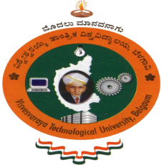

Report on

**“AICTE Activity point Program”**

Submitted for partial fulfillment of the requirement for the award of the degree of

**Bachelor of Engineering**

**in**

**Electrical and Electronics Engineering**

**Submitted by**

Madhu Gowda h k-4AD18EE015



**Department of Electrical and Electronics Engineering**

**ATME College of Engineering**

**13th K.M stone, Mysuru-Kanakapura- Bengaluru road, Mysuru-570028**

**2021-2022**

**ATME College of Engineering, Mysuru-570028**

|  |  |  |
| --- | --- | --- |
| Name | of Student | MADHU GOWDA H K |
| USN of Student | | 4AD18EE015 |
| Department | | Electrical and Electronics Engineering |
| Entry | to Program | Regular |
| Activity Points | | 50-Regular |
| Titles of Activity Under Taken | | * Swatch Bharath Activity * Creating Public Awareness about Swatch Bharath Abhiyaan |
| Places of Activity | | * Chikka Ankanahalli * Bangar pete(T) |
| Dates | of Activity | 10-05-2022 to 25-05-2022 |
| Number Of Weeks or Hours involved | | 80 Hours |

**REPORT ON AICTE ACTIVITY POINT**

Activity Point Earned

**TABLE OF CONTENT**

|  |  |  |
| --- | --- | --- |
| **Sl. Number** | **Title** | **Page Number** |
| **1** | **Swatch Bharath Activity**   1. Executive Summary or Abstract Introduction | **4** |
| **2** | Conduction of activity and photographs | **5-6** |
| **3** | My Contribution and outcome | **6** |
| **4** | Certificates | **7** |

**SWACHH BHARAT** **ACTIVITY AT CHIKKA ANKANAHALLI**

**GRAMA PANCHAYAT, BANGARAPET[T]**

**Objective:**

1. To motivate the Localite of the chikka ankanahalli village to keep their surroundings clean.
2. Taking initiative and helping them in cleaning the village.
3. Creating awareness of Swatch Bharath in the Villages.
4. **Description:**

As per guidelines from AICTE and VTU, apart from technical knowledge and skills, to be successful as professionals, students should have excellent soft skills, leadership qualities and team spirit and also Students should have entrepreneurial capabilities and societal commitment.

To fulfil this, along with our friends group, We have conducted a Swachh Bharat Program at Chikka ankanahalli, grama panchayat, Bangarapet [T], from 10.05.2022 to 25.05.2022 under AICTE activity number 15 That is contribution to any national level initiative of Government of India Which includes Swachh Bharat as a program in it.

We visited nearby dirty places in that village of bangarpet and started to clean ourselves.

So, we took initiative in Cleaning the surroundings of the village and thereby we created awareness

and importance of Swatch Bharath Andolan and we performed our social responsibilities towards development of clean society in the villages of Karnataka.

Apart from cleaning the village surroundings, we visited the grama panchayat office building of chikka ankanahalli village of bangarpet and we shared our thoughts about the importance and necessity of adopting Swatch Bharath Abhiyaan, which was first initiated by Our honorable Prime Minister Narendra Singh Modi. Thus, we helped them in knowing the importance of Cleanliness in villages.

Department of Electrical and electronics engineering , ATMECE Page 4

1. **Conduction of activity and photographs**

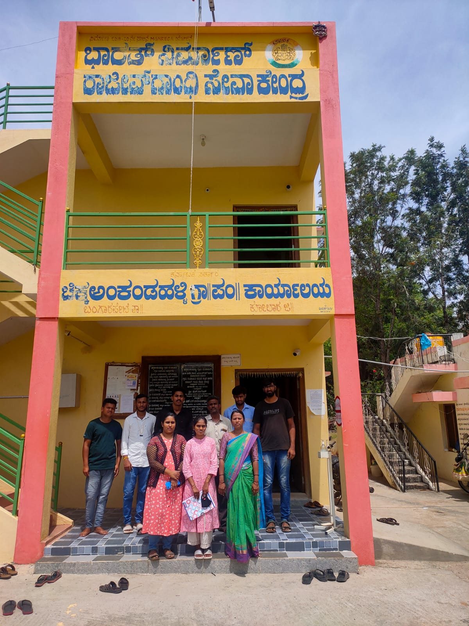

Department of Electrical and electronics engineering , ATMECEPage 5

**3.My Contribution:**

I created the awareness of Swatch Bharath Abhiyaan by taking individual initiatiative in cleaning surroundings of the village “Chikka ankanahalli” of Bangarpet District.

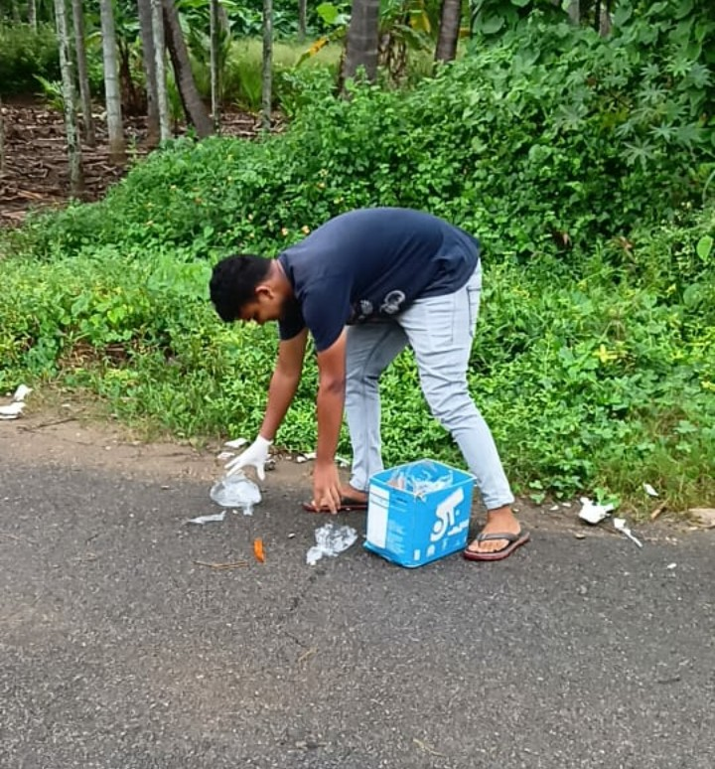

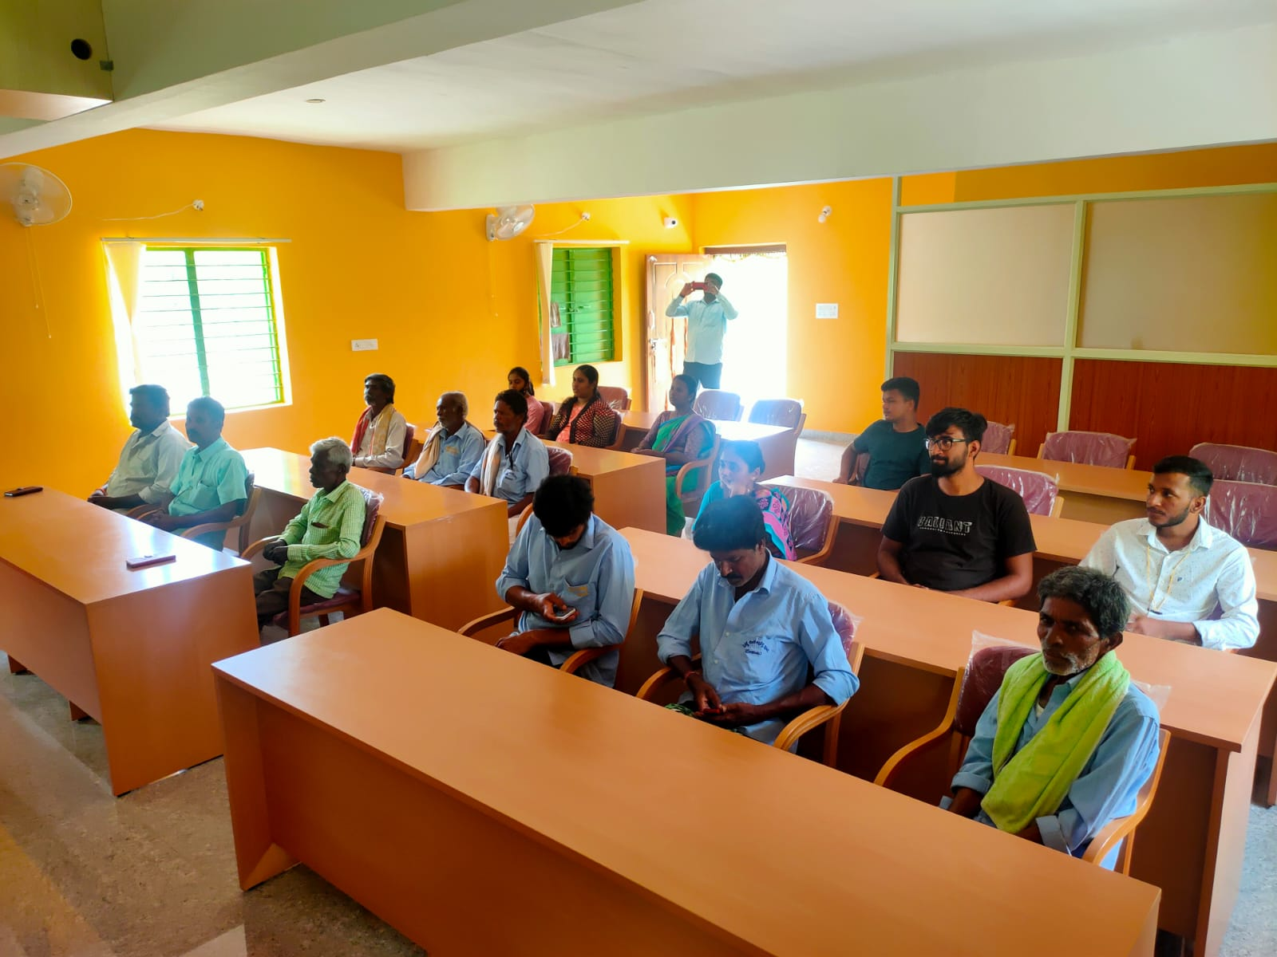

Department of Electrical and electronics engineering ,ATMECE Page 6

**Conclusion :** On Conducting this activity we are able to realize how much Pollution we Causing to our Environment. And we are able to to stop them using “Swatch Bharat Program”and we are able to realize the locales about it

Details of Panchayat :-

Name :- Leelavathi V

Ph no:- 9141280033

**OUTCOME:**

After completion of the Swachh Bharat activity in Chikka ankanahaali grama panchayat, Changes occur among the beneficiaries including members of panchayat. The activity was carried out keeping in mind the objectives of the program.

Department of Electrical and electronics engineering ,ATMECE Page 7

**4. Certificates**

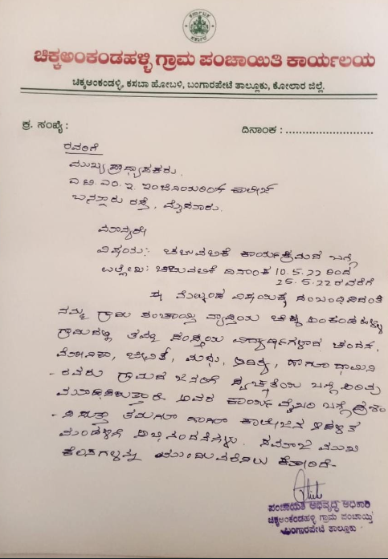

Department of Electrical and electronics engineering ,ATMECEPage 8